Cover Page  LOT # 08812 | 16X20X36 R8  PLENUM BOXED RAW/END CAP  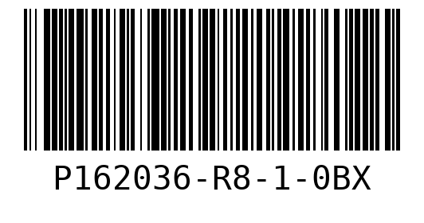  WO 147023  LOT 08812  QTY 20
16X25X36 R8  PLENUM BOXED RAW/END CAP  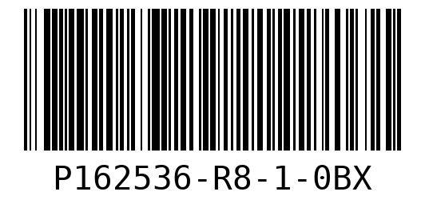  WO 147026  LOT 08812  QTY 20 | 20X20X36 R8  PLENUM BOXED RAW/END CAP  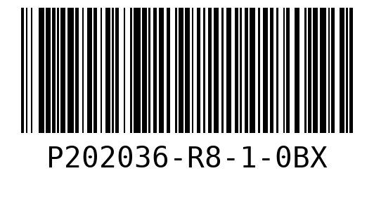  WO 147030  LOT 08812  QTY 30
20X25X36 R8
PLENUM BOXED RAW/END CAP
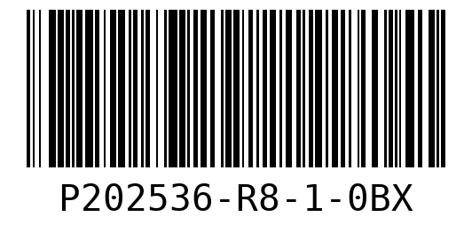
WO 147033
LOT 08812
QTY 5

Sheet # 1  LOT # 08812 | 16X20X36 R8  PLENUM BOXED RAW/END CAP  WO 147023  LOT 08812
16X20X36 R8  PLENUM BOXED RAW/END CAP  WO 147023  LOT 08812 | 16X25X36 R8  PLENUM BOXED RAW/END CAP  WO 147026  LOT 08812
16X25X36 R8  PLENUM BOXED RAW/END CAP  WO 147026  LOT 08812 | 16X25X36 R8  PLENUM BOXED RAW/END CAP  WO 147026  LOT 08812

16X25X36 R8  PLENUM BOXED RAW/END CAP  WO 147026  LOT 08812 | 16X25X36 R8  PLENUM BOXED RAW/END CAP  WO 147026  LOT 08812
20X20X36 R8  PLENUM BOXED RAW/END CAP  WO 147030  LOT 08812 | 20X20X36 R8  PLENUM BOXED RAW/END CAP  WO 147030  LOT 08812
20X20X36 R8  PLENUM BOXED RAW/END CAP  WO 147030  LOT 08812 | 20X20X36 R8  PLENUM BOXED RAW/END CAP  WO 147030  LOT 08812

Sheet # 2  LOT # 08812 | 16X20X36 R8  PLENUM BOXED RAW/END CAP  WO 147023  LOT 08812
16X20X36 R8  PLENUM BOXED RAW/END CAP  WO 147023  LOT 08812 | 16X25X36 R8  PLENUM BOXED RAW/END CAP  WO 147026  LOT 08812
16X25X36 R8  PLENUM BOXED RAW/END CAP  WO 147026  LOT 08812 | 16X25X36 R8  PLENUM BOXED RAW/END CAP  WO 147026  LOT 08812

16X25X36 R8  PLENUM BOXED RAW/END CAP  WO 147026  LOT 08812 | 16X25X36 R8  PLENUM BOXED RAW/END CAP  WO 147026  LOT 08812
20X20X36 R8  PLENUM BOXED RAW/END CAP  WO 147030  LOT 08812 | 20X20X36 R8  PLENUM BOXED RAW/END CAP  WO 147030  LOT 08812
20X20X36 R8  PLENUM BOXED RAW/END CAP  WO 147030  LOT 08812 | 20X20X36 R8  PLENUM BOXED RAW/END CAP  WO 147030  LOT 08812

Sheet # 3  LOT # 08812 | 16X20X36 R8  PLENUM BOXED RAW/END CAP  WO 147023  LOT 08812
16X20X36 R8  PLENUM BOXED RAW/END CAP  WO 147023  LOT 08812 | 16X25X36 R8  PLENUM BOXED RAW/END CAP  WO 147026  LOT 08812
16X25X36 R8  PLENUM BOXED RAW/END CAP  WO 147026  LOT 08812 | 16X25X36 R8  PLENUM BOXED RAW/END CAP  WO 147026  LOT 08812

16X25X36 R8  PLENUM BOXED RAW/END CAP  WO 147026  LOT 08812 | 16X25X36 R8  PLENUM BOXED RAW/END CAP  WO 147026  LOT 08812
20X20X36 R8  PLENUM BOXED RAW/END CAP  WO 147030  LOT 08812 | 20X20X36 R8  PLENUM BOXED RAW/END CAP  WO 147030  LOT 08812
20X20X36 R8  PLENUM BOXED RAW/END CAP  WO 147030  LOT 08812 | 20X20X36 R8  PLENUM BOXED RAW/END CAP  WO 147030  LOT 08812

Sheet # 4  LOT # 08812 | 16X20X36 R8  PLENUM BOXED RAW/END CAP  WO 147023  LOT 08812
16X20X36 R8  PLENUM BOXED RAW/END CAP  WO 147023  LOT 08812 | 16X25X36 R8  PLENUM BOXED RAW/END CAP  WO 147026  LOT 08812
16X25X36 R8  PLENUM BOXED RAW/END CAP  WO 147026  LOT 08812 | 16X25X36 R8  PLENUM BOXED RAW/END CAP  WO 147026  LOT 08812

16X25X36 R8  PLENUM BOXED RAW/END CAP  WO 147026  LOT 08812 | 16X25X36 R8  PLENUM BOXED RAW/END CAP  WO 147026  LOT 08812
20X20X36 R8  PLENUM BOXED RAW/END CAP  WO 147030  LOT 08812 | 20X20X36 R8  PLENUM BOXED RAW/END CAP  WO 147030  LOT 08812
20X20X36 R8  PLENUM BOXED RAW/END CAP  WO 147030  LOT 08812 | 20X20X36 R8  PLENUM BOXED RAW/END CAP  WO 147030  LOT 08812

Sheet # 5  LOT # 08812 | 16X20X36 R8  PLENUM BOXED RAW/END CAP  WO 147023  LOT 08812
16X20X36 R8  PLENUM BOXED RAW/END CAP  WO 147023  LOT 08812 | 16X20X36 R8  PLENUM BOXED RAW/END CAP  WO 147023  LOT 08812
20X20X36 R8  PLENUM BOXED RAW/END CAP  WO 147030  LOT 08812 | 20X20X36 R8  PLENUM BOXED RAW/END CAP  WO 147030  LOT 08812

20X25X36 R8  PLENUM BOXED RAW/END CAP  WO 147033  LOT 08812 | 20X25X36 R8  PLENUM BOXED RAW/END CAP  WO 147033  LOT 08812
20X25X36 R8  PLENUM BOXED RAW/END CAP  WO 147033  LOT 08812 | 20X25X36 R8  PLENUM BOXED RAW/END CAP  WO 147033  LOT 08812
20X25X36 R8  PLENUM BOXED RAW/END CAP  WO 147033  LOT 08812 | Sheet # 6  LOT # 08812

16X20X36 R8  PLENUM BOXED RAW/END CAP  WO 147023  LOT 08812 | 16X20X36 R8  PLENUM BOXED RAW/END CAP  WO 147023  LOT 08812
16X20X36 R8  PLENUM BOXED RAW/END CAP  WO 147023  LOT 08812 | 16X20X36 R8  PLENUM BOXED RAW/END CAP  WO 147023  LOT 08812
16X20X36 R8  PLENUM BOXED RAW/END CAP  WO 147023  LOT 08812 | 16X20X36 R8  PLENUM BOXED RAW/END CAP  WO 147023  LOT 08812

16X20X36 R8  PLENUM BOXED RAW/END CAP  WO 147023  LOT 08812 | 16X20X36 R8  PLENUM BOXED RAW/END CAP  WO 147023  LOT 08812
20X20X36 R8  PLENUM BOXED RAW/END CAP  WO 147030  LOT 08812 | 20X20X36 R8  PLENUM BOXED RAW/END CAP  WO 147030  LOT 08812
20X20X36 R8  PLENUM BOXED RAW/END CAP  WO 147030  LOT 08812 | 20X20X36 R8  PLENUM BOXED RAW/END CAP  WO 147030  LOT 08812

Sheet # 7  LOT # 08812 | 16X20X36 R8  PLENUM BOXED RAW/END CAP  WO 147023  LOT 08812
20X20X36 R8  PLENUM BOXED RAW/END CAP  WO 147030  LOT 08812 | 20X20X36 R8  PLENUM BOXED RAW/END CAP  WO 147030  LOT 08812
20X20X36 R8  PLENUM BOXED RAW/END CAP  WO 147030  LOT 08812 | 20X20X36 R8  PLENUM BOXED RAW/END CAP  WO 147030  LOT 08812

20X20X36 R8  PLENUM BOXED RAW/END CAP  WO 147030  LOT 08812 | 20X20X36 R8  PLENUM BOXED RAW/END CAP  WO 147030  LOT 08812
20X20X36 R8  PLENUM BOXED RAW/END CAP  WO 147030  LOT 08812 | 20X20X36 R8  PLENUM BOXED RAW/END CAP  WO 147030  LOT 08812

